**HAPPIEST MINDS TECHNOLOGIES LTD.**

**Workshop Automation Proposal for Hyundai AutoEver**



S

**Copyright Information**

This document is the exclusive property of Happiest Minds Technologies Ltd. (“Happiest Minds”). The recipient agrees that they may not copy, transmit, use, or disclose the confidential and proprietary information in this document by any means without the expressed and written consent of Happiest Minds. By accepting a copy, the recipient agrees to adhere to these conditions to the confidentiality of Happiest Minds practices and procedures.

**Confidentiality Clause**

This document is being submitted to HYUNDAI AUTOEVER Enterprises Ltd by Happiest Minds Technologies Ltd. on the understanding that the contents of this document will not be divulged to any third party without the express written consent of the parties. It is also understood that the parties will not divulge any confidential information about HYUNDAI AUTOEVER that it may have access to during this interaction.

**Disclaimer**

This document has been prepared based on the information provided by HYUNDAI AUTOEVERL. Wherever proposed, the solutions and/or services mentioned are based on the requirements defined and understood by us at the time of preparing this document. While every effort has been made to make this document as accurate as possible, there might be changes to the document based on the subsequent discussions.

Table of Contents

1. Executive Summary 3

2 Requirement Details 3

2.1 Requirements 3

2.2 In Scope 3

2.3 Out of Scope 3

2.4 Supported OS, Browser and Android versions 4

2.5 Supported Screen Resolution 4

2.6 Assumptions 4

2.7 Dependencies on HYUNDAI AUTOEVER 5

3 Solution Consideration 5

3.1 Solution Architecture 5

3.1.1 Design Considerations 6

3.2 Testing and Validation 8

3.3 User Experience (UX) 11

3.4 Proposed DevOps Approach 11

3.5 Technology Stack – Indicative 12

4 Project Delivery Approach 12

4.1 Governance Model 13

4.2 Execution Schedules And Deliverables 14

4.3 Project Communication Model 14

4.4 Risk and Mitigation Plan 14

4.5 Execution Schedule and Deliverables 14

4.6 Change Request Management 15

4.7 Acceptance Criteria 15

5 Commercials 16

# Executive Summary

Happiest minds would like to thank HYUNDAI AUTOEVER for giving us this opportunity to bid for this RFP for the Workshop automation Platform. HYUNDAI AUTOEVER intends to to digitization of existing workshop automotive service centers to improve their efficiency and enhance the customer experience. The Workshop Automation Application is a powerful software solution designed to streamline the service process and optimize workflows. The application offers a suite of features that enable service centers to automate manual processes, optimize resource allocation, and improve communication between staff and customers

The problem with current service centers is that they rely on semi manual processes, which are time-consuming and prone to errors. This can lead to delays, increased costs, and decreased customer satisfaction. By digitizing the service process, service centers can reduce these issues and improve the overall service experience.

HYUNDAI AUTOEVER Workshop Automation Application addresses these challenges by automating many of the manual processes involved in service management. The application includes features such as real-time monitoring of service activities, Job scheduling and allocation of resources, streamlined communication between staff and customers, and comprehensive reporting and analytics. The application also offers the ability to optimize workflows to reduce downtime and increase productivity

By implementing the Workshop Automation Application, service centers can expect to see significant improvements in efficiency, reduced costs, increased customer satisfaction, and enhanced quality control. The application frees up time and resources for more valuable tasks, such as customer service and business development. It also enables service centers to deliver personalized service and recommendations, enhancing the overall customer experience.

In conclusion, the digitization of existing service is essential for automotive service centers looking to remain competitive in today's market. The Workshop Automation Application is a powerful tool that can help service centers achieve their goals of improving efficiency, reducing costs, and enhancing customer satisfaction. With its advanced features and user-friendly interface, it is a must-have for any service center looking to improve their operations and stay ahead of the competition.

Based on our experience of having collaborations with multiple customers in a similar domain, we believe that Happiest minds would provide an effective solution to automate workshop workflows and service center.

Happiest minds are excited to bid for this RFP from HYUNDAI AUTOEVER and we believe that Happiest Minds is well placed to be the partner of choice for HYUNDAI AUTOEVER.

# Requirement Details

## Requirements

1. A screen that displays a list of scheduled appointments and repair orders.
2. Develop role-based access control for Workshop automation application.
3. Implement login authentication for each role.
4. Different personas need to be created for Workshop automation based on type of device a
   * Administrator
   * Service Advicer
   * Floor In-charge
     + Service advisors and Floor In charge should have access to the application through desktop.
     + Service advisors and Floor In charge should be able to view and manage the Repair Order (RO) list, estimate, and job card.
   * Technician
     + Technician should have access to the application through Tablet.
     + Technicians should be able to view assigned jobs and update the status after job.
   * Washing Staff
     + Washing Staff should have access to the application through Tablet.
     + Washing staff should be able to view assigned vehicles and update the status after washing.
   * Final Inspector
     + FI should have access to the application through Tablet.
     + FI should be able to view assigned vehicles and update the status after final inspection.
   * Customer Care Excutive
     + CCE should have access to the application through Tablet.
     + CCE should be able to view customer feedback and update customer details.
5. Different personas need to be created for Workshop automation Kiosk and Dealer BOS System based on type of device.
   * Kiosk Digital BOS -Admin
   * Kiosk Client – Admin
   * Digital Signage Client- Admin
6. Integration with DMS API:
   * The application should integrate with the dealership's Dealer Management System (DMS) API to retrieve vehicle and customer details.
   * Part Master and Labor Master
   * Repair Order API
   * User Master API
   * Dealer Master API
7. A screen that allows the user to search for a specific vehicle by make, model, or license plate number.
8. Display a list of matching vehicles with owner details and service history.
9. The option to view customer history and previous service records.
10. The screen should generate an estimated quotation for the selected service request based on the vehicle and customer details entered.
11. The screen should allow the user to modify the quotation as necessary, based on additional services requested or any changes in pricing.
12. Customer Demand: The application should be able to capture customer requirements and specifications related to the service needed, including any additional requests or customizations.
13. WA application should be able to create a repair order by integrating with the DMS API to fetch the necessary customer and vehicle information. Users should be able to create a repair order with details such as reason for repair, estimated cost, and expected completion date.
14. Ability to select and fill out relevant checklist items based on customer's reported issues or concerns.
15. Ability to take and upload images or videos related to the customer's reported issues.
16. Checklist must be completed, and images/videos uploaded before vehicle is handed over to technician for repair work, for wash and final inspection.
17. Checklist and images/videos should be accessible to technicians for reference during repair work.
18. WA Application should have the ability to generate and send a survey request to customers via a customer care executive.
19. Hyundai wants to keep a track of status of repair order and generate a report based on daily.
20. Workshop status reports summary.
    * Usage report - Date wise Usage/Utilization report
    * DSI Statistics report-
    * Washing Statistics report
    * SOP Statistics report
      + Monthly Sop report
      + SA wise SOP report
    * FI Statistics report
      + Monthly FI report
      + Daily FI report
      + FI rejection report
    * Workshop Reports
      + TC,Bay Efficiency
      + Bay revenue
      + SA revenue
      + Bay utilization
    * VTM reports
      + RO VS productivity
      + Region Wise
      + Daily Productivity
    * Dealer BOS portal- Admin

## In Scope

* Design and Development of
  + WA Web and Analytics Portal
  + WA Android App
  + WA Kiosk & WA Digital Signage
  + WA BOS Portal (Dealer)
* User Experience (UX)
* System Testing
* Application Security (OWSAP 10)
* Performance Testing (6 key scenarios)
* UAT Support
* Warranty Support (4 Weeks)
* Support for English Language only
* Setup the Infrastructure on AWS cloud (2 environments) along with Hyundai AutoEver DevOps team

## Out of Scope

* Requirement
  + Offline Support in Android app – Internet is mandatory to access the android app.
  + iOS App
* Multi-tenant Support
* Changes in Dealer Management System (DMS)
* User Experience
  + No UX/UI design for TV form factor
* Test Automation (API and UI)
* PEN Testing
* Multi-lingual testing
* User Manual, SOP, Runbook
* Post Warranty Support
* Infrastructure automation
* Infrastructure configuration and capacity planning
* Any tool/ third party integration other than mentioned on the requirement section
* Any items not mentioned in the “In Scope” section
* App submission to Play Store

## Supported OS, Browser and Android versions

The user interface will be supported and tested on the “latest Major.Minor version and Major.Minor– 1” at the start of the project for the following browsers:

|  |  |  |  |  |  |
| --- | --- | --- | --- | --- | --- |
| **Application** | **Platform** | **Device Orientation** | **Device**  **(Latest Models as of March 2023)** | **Version** | **Testing Scope** |
| WA Android App | Android | Tablet: Landscape | Samsung Tablet 1 [~ 10 inch] | Latest version | Full Testing |
|  |  | Tablet: Landscape | Samsung Tablet 2 [~ 8 inch] | Previous version to latest | Sanity |
| WA Web and Analytics Portal, and Kiosk Client | Windows 10 (Laptop) |  | Chrome Browser | Latest version | Full Testing |
|  |  |  | Edge Browser | Latest version | Sanity |
|  | Tablet | Tablet: Landscape | Chrome Browser | Latest version | Sanity |

## Supported Screen Resolution

The below mentioned screen resolution will be supported for Web Portal:

* + Resolution equal to or above 1280 x 768 pixels (Desktop/Laptop only)

## Assumptions

**Technical**

* User availability for assignment in a workflow is provided from DMS. If a user not available on a day, then DMS will not provide that user for assignment.
* Standard Video player controls such as start/pause/stop, full screen mode, play rate of 1x, 1.2x, 1.5x etc.
* Max. video of size 500MB will be recorded and uploaded.
* Data Migration
  + Customer would share the existing production data in staging environment for testing data migration scripts and fixing any data issues.
  + Production data is expected to be in proper format and no data cleansing is expected and planned for the data migration.
  + 15 tables have been considered for Data migration.
  + Data to be migrated will be provided as file dump.
* DMS APIs will be provided to get or update metadata and work order information from DMS system.
* DMS API access from Workshop Automation system is through an API key.
* WA Kiosk application will be web application and would require internet connection for rendering.
* All reports will be generated using the data captured in Workshop automation application as the required data from DMS will be synced to Workshop automation application.

**UX**

* During both the conceptual and actual UX design proposals, only two reviews and iterations are factored into the current plan and estimates.
* Adobe XD shall be used as the primary UX tool for creating the UX deliverables e.g., UI assets that is elements, components, templates etc. as well as for creating a clickable UX prototype for review and collaboration purposes. If any other UX tool e.g., Sketch, Figma etc. is required or preferred to be used on this project, Hyundai AutoEver shall procure and provide the required licenses for it.
* Hyundai AutoEver shall provide, as needed, the content (text, graphic, images etc.) for various screens / pages considered in this scope as needed.
* Happiest Minds shall get access to the users and business stakeholders for performing usability testing or otherwise, we may leverage services offered by online tool such as usertesting.com, userbrain, userzoom. Hyundai AutoEver shall procure required credits or purchase subscription for online tools (mentioned earlier) to carry out testing.
* For Wireframing and Visual mock-up, mobile and tablet screens and form factors are considered and accounted for in the efforts and estimate.
* The screen orientation considered for tablet is landscape.

## Dependencies on Hyundai AutoEver

|  |  |
| --- | --- |
| **Dependency Factors** | **To be available by** |
| Product owner for the knowledge transition of the application, clarification, and review of the user stories | Start of the project |
| Technical SPOC for feedback and clarifications | Start of the project |
| Provide any coding guideline or standards that happiest minds must follow for component implementation | Start of the project |
| Access to existing web and android application for requirement and workflow documentation | Start of the project |
| Scheme of the existing Web & Android app to create data migration scripts | As needed during the project |
| Access and documentation Hyundai AutoEver identity management system for integration | As needed during the project |
| Kiosk system should be provided by customer for testing | As needed during the project |
| Test strategy /plan/ cases shall be reviewed and accepted by Hyundai AutoEver before test execution starts. | As needed during the project |
| Review UAT Test Case document | As needed during the project |
| Response to Happiest Minds’ queries within two business days. Any delays in response might have an impact on the effort and schedule & will be treated as a Change Request, | As needed during the project |
| Feedback on the deliverables for each milestone must be provided within 3 days of the delivery by Happiest Minds, else, they shall be deemed accepted | During entire project engagement |
| Azure account | Start of the project |
| Code repository access | Start of the project |
| Happiest Minds shall be provided with the branding guidelines that is logo artwork source files and its usage instructions / guidelines, if any. | Start of the project |
| Happiest Minds shall be provided with any DLS (Design Language System) i.e., component library being used by Hyundai AutoEver, meant for designing mobile / web application’s user interfaces, if any. | Start of the project |
| Happiest Minds shall get access to the users and business stakeholders for reviewing and validating design ideas (wireframes) and performing usability testing on the clickable prototypes before actual implementation. | Start of the project |
| To empathize with the actual users effectively, we shall seek to have relevant details such as demography as well as other personal characteristics of the user groups who will be using the app. | Start of the project |
| Happiest Minds shall be provided with insight and key take-away gathered as part of design thinking workshops, user research / testing activity being carried out already. | Start of the project |
| The review comments by Hyundai AutoEver stakeholders on design / proposals will be provided. | Within 48 hours |

# Solution Consideration

## Solution Architecture

## Design Considerations

* Hyundai AutoEver Workshop Automation system will be built on a microservices architecture for better scalability and reliability.
* It is a layered architecture with separation concern to various layers such as API layer, Services, Data layer.
* All the client requests will be catered through API Management Services in a secured manner.
* Microservice foundations such as security, caching, logging and monitoring will be used in all the services.
* Transactional data will be stored in Relational DB and the promotional content such as videos and posters will be stored Azure Blob storage.

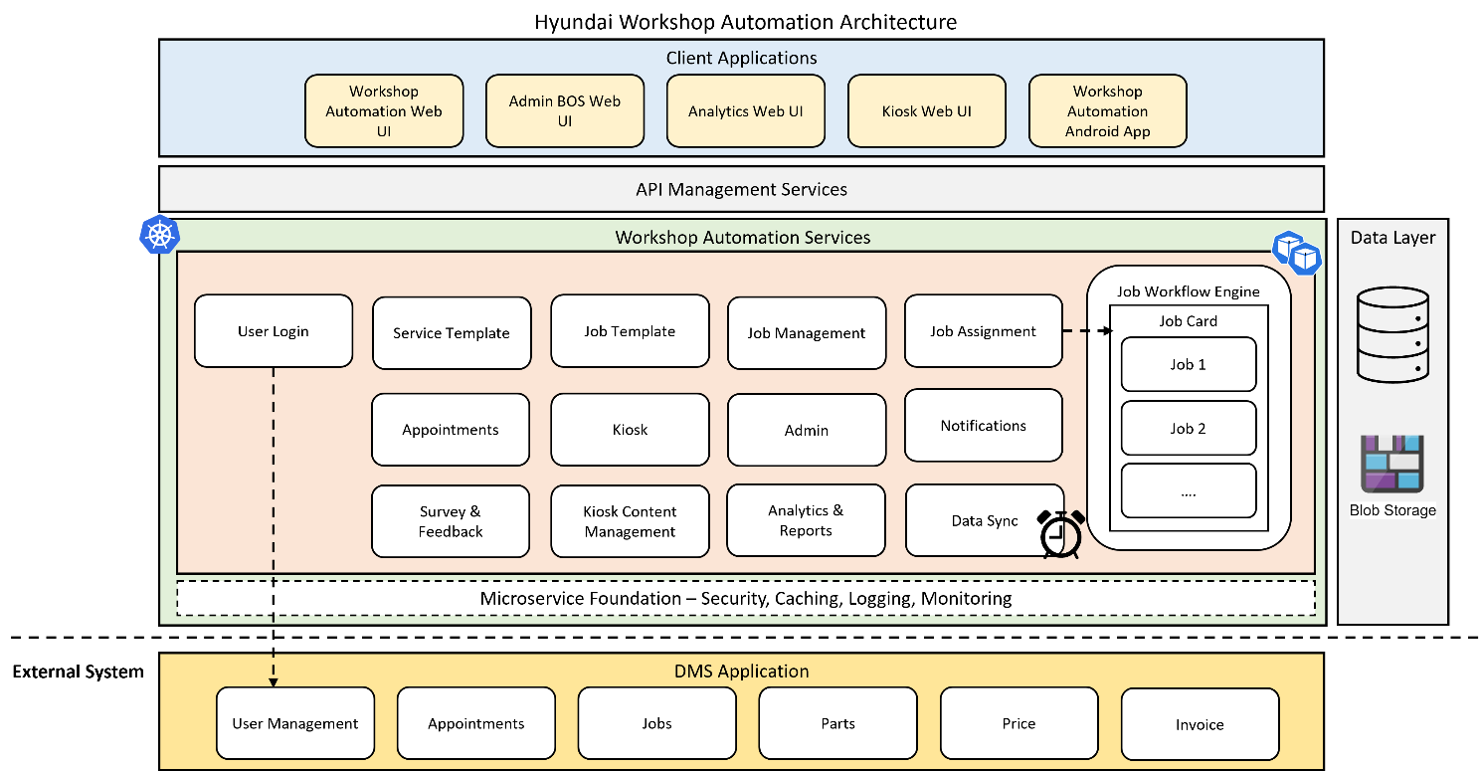

* + 1. Authentication
* Workshop Automation System will have multiple users associated with various roles such as Service Advisor, Job Controller, Technician etc.
* User identities and credentials are created and managed in DMS.
* User login will be authenticated through a REST API call in DMS using an API key.
  + 1. Service Template
* Workshop Automation System will be modeled to build various Service Templates for Free service, Paid service etc.
* Service Template model will capture all check list for the type of service and customer requested repairs.
* Once service type is selected by the Advisor then Service template of that service type will be displayed.
  + 1. Job Template
* Workshop Automation System will be modeled to build various Job templates based on the services requested by the customer in the service template.
* Job Template model will capture all Jobs to be carried out for the service request.
* Using the Job template, the Job card will be created. Based on the Job Card, Job Workflow will be created in the Business Process Management module.
  + 1. Job Assignment & Workflow Engine
* To work on the jobs available in the Job Card, people will be assigned for each job in the workflow associated with a Job Card.
* On starting a Job Card, the Job workflow is triggered and flows through various stages based on the action performed on each Job.
* Job workflow created for a Job card will persist the jobs, rules associated with jobs and its actions in DB.
* Workflow state is persisted in the DB.
* Workflow engine run through the flow of jobs as defined with rules, actions and assignments.
  + 1. Notifications
* Notifications to customers are sent over SMS. Workshop Automation System will be integrated with a SMS service provider to send SMS.
* Job completion status of a job in a workflow is done using Push notification.
* The next job to be performed for a user will be available in his Inbox present in the Workshop automation system.
  + 1. Data Sync
* Data such as Customer, Appointment, Part Label, Price, Invoice are available in the DMS.
* These data will be synced periodically to Workshop Automation system from DMS over a REST API through a scheduled job.
* Similarly, the Job card details created in Workshop Automation system will be pushed to DMS periodically over REST API
  + 1. Admin
* Admin application will be developed as a separate web application. But, all the required backend API will be provided by the same backend service which caters to Workshop automation use cases.
* Admin application will manage the applications settings such as Display, language, time, notices and messages for both Workshop automation application and Kiosk Client application.
* All the promotional content such as videos and posters are uploaded through Admin application. The video and images will be uploaded to Blob storage and the resource URL of blob storage will be persisted in the relational DB for that entity.
* It will provide the necessary data model and application infrastructure to manage the settings and promotional content.
  + 1. Analytics and Reports
* All reports will be generated using the data captured by the Workshop automation application in the relational database.
* SQL queries and views will be created to generate the reporting data from DB and will be rendered in UI.
* Based on user role the list of reports will differ. The access to a report is based on role privileges.
  + 1. Kiosk & Content Management
* Kiosk application will be developed as a separate web application. But, all the required backend API will be provided by the same backend service which caters to Workshop automation use cases.
* Kiosk will have content delivery page to render the posters and play the videos.
* The content are delivered using the Blob storage content URL available as part for the entity.
  + 1. Android Mobile App
* Technician app will cover the complete workflow process for technicians and final inspectors and will be available in the android app.
* Android app will be developed in React Native. The app will invoke a WebView to load the web pages developed using ReactJS.
* The web pages for the WebView will be served from the Workshop automation web application.
* Any customizations or native features required for android app will be implemented using react native in the Android app.

## Testing and Validation

* + 1. Testing Life Cycle

The proposed testing process will follow the detailed testing planning and execution cycle for a System Test Life Cycle (STLC). A brief overview of the testing framework is provided below:

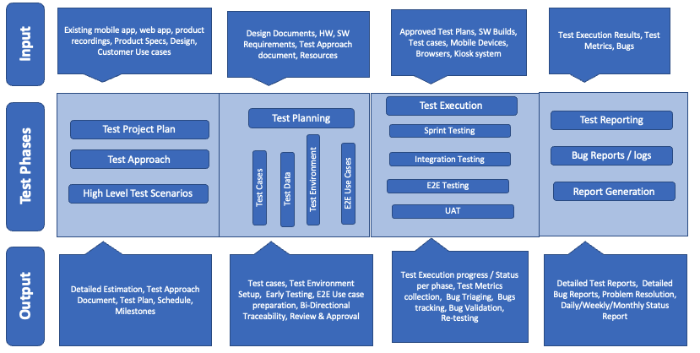

* + 1. Test Types Considered

|  |  |  |  |
| --- | --- | --- | --- |
| **Application / Sub System** | **Test Types** | **Remarks** | **Artifacts** |
| Web App [Workflow Automation – web App, Analytics Portal, Admin Portal] | Use Case / Functional Tests | All the functional use cases / Test scenarios shall be tested with valid and invalid data sets.  Applicable user persona:   * Service Advisor * Floor In-charge * Washing team * CCE | Test Scenarios, Test Data Models and Excel Test cases |
| Browser Compatibility Tests | * Happy paths only * Covering all UI screens | Excel Test cases |
| User Experience (UX) Tests | * Search with various user persona * Page navigations * Test with different screen sizes | Excel Test cases |
| Report tests | * Analytical reports * Print formats | Excel Test cases |
| Performance Tests | * Total Scenarios: 6 * Test all the happy paths by loading the system with 50, 100, 200, 300, 400 and 500 users * Response Time: TBD | Excel Test cases |
| Application Security Tests | * OWASP 10 * Infrastructure / Penetration Testing is not considered in the scope | Excel Test cases |
| DMS API | API Tests | Two levels shall be considered for API Testing:   * Atomic API tests: Individual APIs are tested with Valid and Invalid Data * API Chaining Tests: APIs will be chained as per the identified use cases flows and various integration points and tested. | Postman Collection |
| Mobile App | Use Case / Functional Tests | All the functional use cases / Test scenarios shall be tested with valid and invalid data sets.  Applicable user persona:   * Technician * Final inspector | Test Scenarios, Test Data Models and Excel Test cases |
| Device Compatibility Tests | * Happy paths only * Covering all UI screens | Excel Test cases |
| User Experience Testing | * focus on the user experience in terms of navigations, number of steps to get a page / detail, ease of navigation across pages, page load times, response times for event on the screen etc. * focus on the overall usability of the system by end-user perspective and how user can do ease of use, flexibility of handling controls (via mouse, keyboards), ease of adaption of changes to interfaces at the components level etc. | Excel Test cases |
| Installation/Upgrade Tests | * Ease of Installation * Upgrade and local data should be preserved. * First time launch performance Vs Re-install performance | Excel Test cases |
| Interrupt Tests | * Calls, SMS, Alerts, Headphones, Bluetooth Connections, Sleep / Awake, Low Battery, Notifications, App Switching, lock / unlock | Excel Test cases |
| Kiosk | Use Case / Functional Tests | * All the functional use cases / Test scenarios shall be tested with valid and invalid data sets   Applicable user Persona:   * BOS Admin * Dealer * Digital Signage Client | Excel Test cases |
| Updates as part of Data Migration | Data Testing | * Identify the scope of test data [include/exclude data], Collect the data [no of rows in each table] and data flows. Then prepare the test cases to be executed. * Process the data and check in new system. Data should match in current system and new system. Execute the migration tests and check for any data issues. * Post Migration checks * Validate the existing data [users, jobs, reports etc.] in new system. Also check the new data creation is showing perfectly. * Check for data mismatch cases like data type changed, storing format is changed * Verify the users from the old system can continue to use both the old system and new system * Any data addition in the new application should not reflect on the old system * End-to-End test cases should be executed, and data should be stored in the new system | Test Scenarios, Test Execution reports |
| Workshop Status Reports |  |  |  |

* + 1. Testing – Compatibility Matrix

Testing will be carried out in below agreed versions of devices upon mutual agreement with Hyundai AutoEver and Happiest minds.

|  |  |  |  |
| --- | --- | --- | --- |
| **Platform** | **Device  (Latest Models as of March 2023)** | **Version** | **Testing Scope** |
| Android | Samsung Tablet 1 | Latest version | Full Testing |
| Samsung Tablet 2 | Previous version to latest | Sanity |
| Windows 10 (Laptop) | Chrome Browser | Latest version | Full Testing |
| Edge Browser | Latest version | Sanity |

* + 1. Test Levels Considered

Each of the features in the Application / Subsystems shall be analysed for the test levels and the Test Types (from the previous section) and testing shall be carried out as per the following:

Following test levels are considered in scope of testing:

|  |  |  |  |  |  |
| --- | --- | --- | --- | --- | --- |
| Test Level | Web App [Workflow Automation – web App, Analytics Portal, Admin Portal] | DMS API | Mobile App | Kiosk | Data Migration |
| (Web app & Mobile App) |
| Sprint Level Testing ( QA Env) | ✓  (Story Level) | ✓  (Story Level) | ✓  (Story Level) |  | ✓  (Story Level) |
| Integration Testing ( STG Env) | ✓  (Full Regression) | ✓  (Full Regression) | ✓  (Full Regression) |  | ✓  (Full Regression) |
| End to End Testing (STG Env) | ✓  (Full Regression) |  | ✓  (Full Regression) | ✓  (Full Regression) | ✓  (Full Regression) |
| User Acceptance Testing (PROD) |  |  |  | ✓  (Full Regression) | ✓ (Full Regression) |

Details of each of the test levels are explained below:

### Sprint Testing

Sprint testing shall be carried out as per the identified stories in each sprint. It includes the verification of the portal/application against the requirements on supported devices and browsers combinations. Detailed analysis of different users, possible data that can be input by users and effect of those actions etc. shall be carried out and test scenarios shall be identified.

### Integration Testing

Integration testing is executed to validate the data flow between two or more components/modules. In this case, Service Advisor update, Floor in-charge update & Washing team update should be available for final inspector.

### E2E Testing

This Testing focuses on the E2E use cases that will be prepared by Happiest Minds and will be reviewed and agreed by Customer Stakeholders.

The focus is at an overall solution level such as Service Advisor is creating job, Floor in-charge update, Washing team update, Technician update and final inspection complete.

### User Acceptance Testing

UAT focuses on acceptance testing with Customer Stakeholders on successful completion of which, the identified artefacts are handed over to Customer Stakeholders.

UAT test cases will be identified at the Story, EPIC, Component and E2E User Scenario level and will be shared with the Customer stakeholders. The final UAT cases are agreed upon between Happiest Minds and Customer teams.

UAT testing will be done by the customers and Happiest Minds team would support.

## User Experience (UX)

In our approach to design the UX, we shall start by gathering finer details e.g. attributes and the content belonging to each feature of the app as well as the flow and the context of the existing application which is meant to be used by various roles. This would include doing some user research, desk & in-person(if possible), as this would not only help us in understanding their pain points but also their environment/situation in which they would be using the product. We would then consolidate our findings, reflect and identify any usability or user interface design related issues like cognitive load, motor load, information hierarchy, visual consistency etc. which can be improved.

In our UX designs solutions, we would be focusing to streamline the processes & flows, enhance the UI (look & feel) with consistent styling or visual language & minimise usability issues. We do see quite many forms utilised in the platform, it will be important to implement best practices established for designing forms so that we can improve the overall experience of the users i.e. intuitiveness and overall efficiency of the application.

## Proposed DevOps Approach

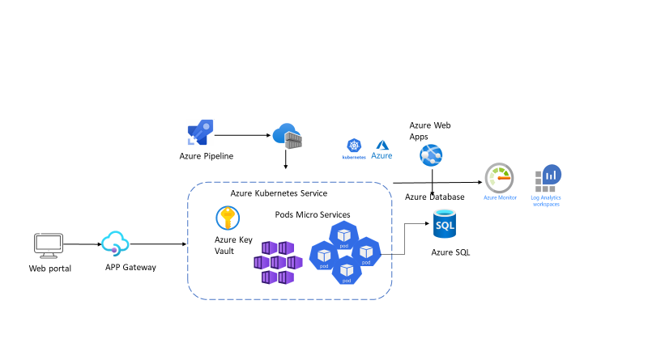The architecture is being approached with the following Azure services integrated across the platform.

* Azure Repo is being configured as a centralized repository and the Repo is configured with multiple branches.
* Azure pipeline is being configured to trigger the pipeline for the build process.
* Pipelines are configured with the multistage build process.
* Node Clusters are created to support multiple pods execution.
* The docker images are stored on the Azure Container Registry as part of the image storage.
* The base images are being created by the DevOps and the image is being updated with multistage build with the required artifacts and the properties file injected as part of the build process.
* Pods are created using the image being provisioned with the above images created from the Azure Container Registry
* Key Vault is configured to retrieve the secrets from the Azure Key Vault
* Azure Storage are configured to store all the required file share services and the data disks configuration.
* Standard process are being integrated as part of Governance execution
* WAF is being configured for the application execution with the PaaS services.
* Application Gateway V2 is configured for the ingress controller execution from the Azure Kubernetes,
* Redis and Caching servers are being part of the integral components with the performance with the available memory
* All the infra structure and applications are being monitoring using Azure monitor, Data dog and Azure Log Analytics.

## Technology Stack – Indicative

|  |  |
| --- | --- |
| **Feature** | **Technology** |
| Microservices | Spring Boot |
| API Gateway | Azure API Management |
| Workflow Engine | jBPM |
| Web UI | HTML, CSS, Bootstrap, MaterialUI, ReactJS |
| Android App | React Native |
| Datastore | * + - * MySQL       * Blob storage |
| Code Quality | SonarQube |
| Containerization | Azure Kubernetes Service, Dockers, Helm, Terraform |
| Container Registry | Azure Container Registry |
| CI/CD | Azure DevOps |
| Application Gateway | Front door for AKS |
| Application Gateway Ingress | Containerized Ingress service for AKS services |
| Monitoring | Log Analytics / Application Insights |
| Azure AD | Provisioning of Users or Service Principal |

# Project Delivery Approach

Agile Scrum framework would be used for project execution. Scrum ensures transparency in communication and creates an environment of continuous progress. The below diagram depicts the model followed by Happiest Minds in Agile projects.

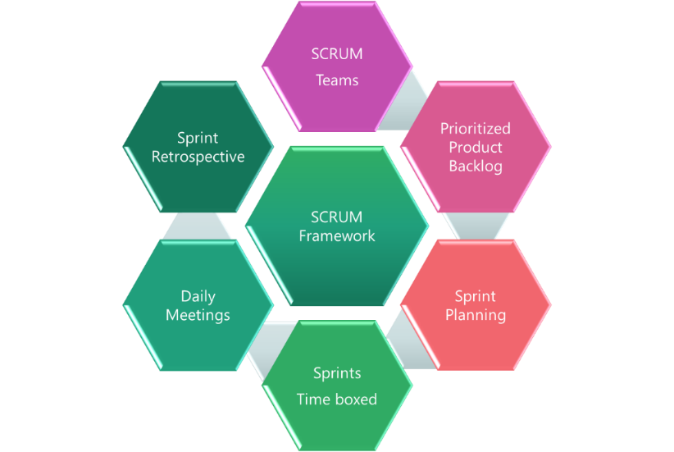

2-week sprint cadence would be followed and there would be a demo at the end of each sprint.

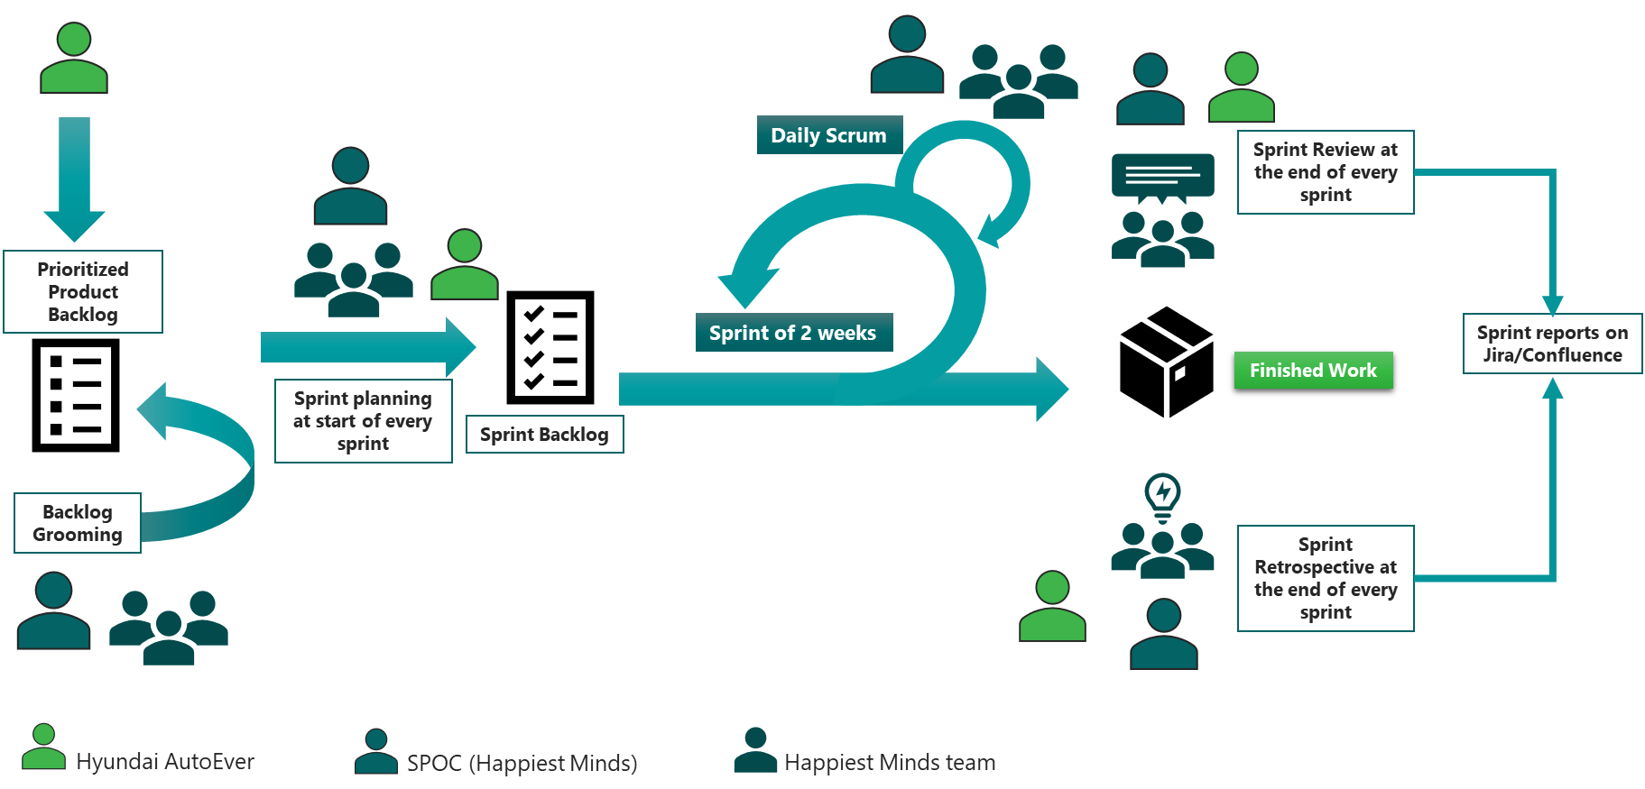

## Governance Model

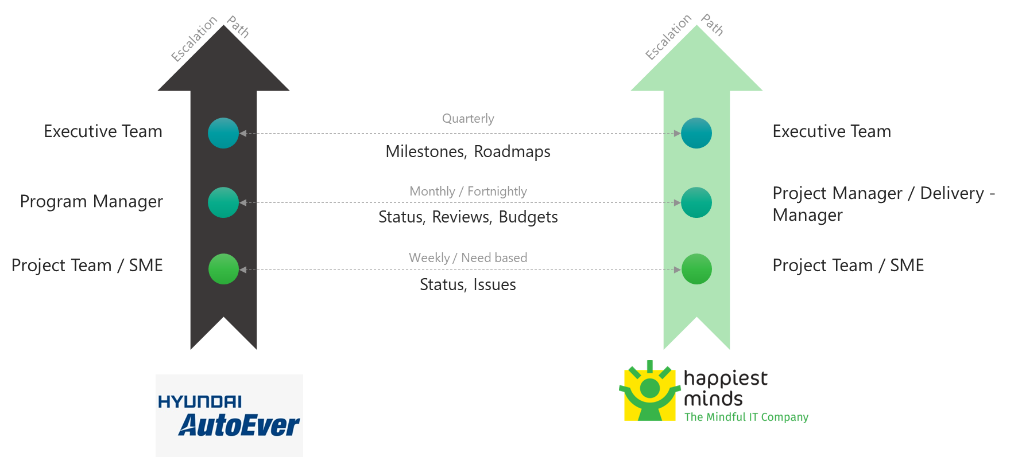

**Project Communication Model**

The communication model will involve the activities below for successful delivery of the project:

1. **Daily Stand-up meetings**: Between Offshore team and Project manager to discuss tasks completed, task planned and any outstanding blocking issues. Hyundai AutoEver is not required to participate in these meetings, but they are welcome to participate if they want to.
2. **Weekly Status Meeting**: Between Project manager at Happiest Minds and Project manager of Hyundai AutoEver to discuss weekly status report and next week’s plan, issues, risk on the on-going phase of the project.
3. **Monthly Operational Meeting**: Between Delivery Manager and Project Manager at Happiest Minds and Project sponsor at Hyundai AutoEver to discuss progress on the project, issues, and risk with resolution for project delivery and commercials. Monthly meetings can be planned if there are plans to continue further enhancements of this MVP.

## Execution Schedules And Deliverables

The delivery schedule is based on our current understanding of requirements. Any changes in scope of the project can have an impact on the cost and schedule of the project.

The project is estimated to be executed in 22 weeks. Happiest Minds proposes to execute the project in sprint-wise execution. Every sprint will be followed by a Sprint Demo. The project plan in terms of what will be delivered in each sprint will be agreed with Hyundai AutoEver before the start of the project.

## Project Communication Model

Happiest Minds proposes the following project-related communication and their frequency:

* Weekly Status Report shall be shared with Hyundai AutoEver at the end of each week along with the planned set of activities for next week.
* Weekly sync up meeting between the Hyundai AutoEver and Happiest Minds project teams to review the progress of the project.
* Quarterly Business review meeting for overall engagement update, roadmaps and opportunity discussion can also be planned that can be attended by Hyundai AutoEver Sponsor, Executives & respective Directors.

## Risk and Mitigation Plan

| **No** | **Risk** | **Mitigation** |
| --- | --- | --- |
| 1 | In the absence of existing application data schema, data volume and data quality, it is hard to provide a scope of data migration and estimation. | To mitigate this risk, we have scoped the migration work to 15 tables migration and data for 1 year. Also, there won’t be any necessity for data cleansing or transformation. Data migration above this would be taken through change request management |
| 2 | There is no clarity on the mechanism of integration with DMS. We are expecting either regular data dump (file) or APIs will be provided for the metadata and workorder | In the absence of the data through file or API, DMS integration will be considered as out of scope |

## Execution Schedule and Deliverables

The delivery schedule is based on our current understanding of requirements. Any changes in scope of the project are expected to have an impact on the cost and schedule of the project.

Following is an indicative plan for the implementation, a detailed one shall be arrived at within the first two weeks of the project start and shared with all stakeholders.

**Assume Project Start Date: (T)**

|  |  |  |  |
| --- | --- | --- | --- |
| **Milestone** | **Due Date in Weeks** | **Owner** | **Deliverables** |
| Project Kickoff | T | Happiest Minds | Kickoff Deck with Team details, Project communication and execution model |
| Requirement, UX and Design | T + 2 | Happiest Minds | Requirement elaboration & documentation  UX design and Wireframes - Part 1  Technical Architecture and Design |
| Milestone – 1 | T + 8 | Happiest Minds | UX design and Wireframes - Part 2  Login  Appointment Listing  Customer Registration  Pre RO and RO registration  Job Card creation  Workflow engine for Job card  Job Allocation  RO search, listing and details  Dashboard - RO listing  Vehicle Search |
| Milestone – 2 | T+ 12 | Happiest Minds | Technician Check list  Final inspector Check list  Washing Check list  Message Center and Notification  RO print, History  Job Schedule  VHC Screen |
| Milestone – 3 | T+16 | Happiest Minds | Admin Settings - Screen display, Menu, Notice, dealer permission  Upload videos and posters  Manage Dealer list  Kiosk -Vehicle status board  Kiosk - Promotions content rendering  Customer survey |
| Milestone – 4 | T+20 | Happiest Minds | Dashboard  Date wise Usage/Utilization report  DSI Statistics  SOP Statistics report  a. Monthly Sop report  b. SA wise SOP report  FI Statistics report  a. Monthly FI report  b. Daily FI report  c. FI rejection report  Washing Statistics report/Washing Statistics  Workshop Reports  a. TC,Bay Efficiency  b. Bay revenue  c. SA revenue  d. Bay utilization  VTM reports  a. RO VS productivity  b. Region Wise  c. Daily Productivity |
| UAT | T+22 | Hyundai AutoEver + Happiest Minds | Data Migration  UAT  Bug fixes |
| Warranty | T+24 | Hyundai AutoEver + Happiest Minds | Bug Fixes |

**Note**: UAT should be completed within 2 weeks from the delivery of the system tested application. Any further time needed shall go through the change management process.

## Change Request Management

Changes to the scope will mean any of the following:

* Change introduced in the application between the proposal and the actual implementation or during the implementation.
* Any changes to the scope of the project as detailed in section “In Scope”
* Invalidation of any of the assumptions detailed in section “Assumptions”
* Any change to the terms and conditions as defined in section “Commercials”
* Non-fulfillment of any of the dependencies detailed in the sections “Dependencies”
* Any delay that happens to the schedule can be attributed to Hyundai AutoEver.

In case of a change request, the scheduled end date for this Project and/or the fees associated may change. Whenever a change is identified, it will be managed as per the below process:

* For any changes to the scope, either Hyundai AutoEver or Happiest Minds will submit a Change Request
* Happiest Minds will issue a Change Order providing the impact of the change to the schedule and/or fees
* Hyundai AutoEver SPOC will review along with Happiest Minds SPOC and mutually agree to either approve or cancel the change order
* Changes will be implemented only after Hyundai AutoEver SPOC approval and signing of the change order form by both the Parties
* For any Hyundai AutoEver dependencies that are not met or issues that are not resolved, which could impact the schedule – Happiest Minds Project Manager will complete a Change Order and inform the Hyundai AutoEver SPOC.

## Acceptance Criteria

* The user story’s acceptance criteria/test cases will be reviewed and mutually agreed upon.
* The Acceptance test case document along with acceptance test environment details would be shared by Hyundai AutoEver and signed off 4 weeks before the start of Acceptance Testing
* Acceptance Testing will be carried out by Hyundai AutoEver team and supported by happiest minds
* Acceptance Testing should be completed within 2 weeks from the delivery of the system tested application
* The acceptance criteria will be passing of the user acceptance test cases with Zero Critical (P0) and High (P1) severity bugs identified

**Defect Severity – Definition:** Definition of Defect Severity and Priority are as below.

|  |  |
| --- | --- |
| **Defect Severity** | **Definition** |
| P0 – Critical | Defect may be a showstopper – that is, it stops the user from using the system further. |
| P1 – High | Defect occurs repeatedly and prevent the user from proceeding in the normal way, but a workaround exists. |
| P2 – Medium | A defect is isolated or does not stop the user from proceeding but is annoying and causing inconvenience. |
| P3 – Low | A defect that in no way affects the performance or functionality. E.g.: Aesthetic issues and grammatical errors in messages. |

* The deliverables would be deemed accepted if there is no response/feedback from Hyundai AutoEver within 2 weeks post release of System Tested Application.

# Commercials

|  |  |
| --- | --- |
| **Description- Development** | **Amount (INR)** |
|  |  |

* Travel: If any travel and boarding/lodging related expenses are incurred during the execution of the project, it will be charged on actuals to Hyundai AutoEver. Happiest Minds will seek prior permission from Hyundai AutoEver before undertaking any such trip.
* Project specific Costs and Expenses: Happiest Minds will provide standard Microsoft Windows based PC hardware and software to its team members at its site for execution of work under this project. Any project specific specialized hardware, software licenses, testing devices or networking/cloud infrastructure required for the project will either be provided by Hyundai AutoEver or will be procured and expensed to Hyundai AutoEver. Happiest Minds will obtain prior written approval from Hyundai AutoEver before procuring or incurring any project specific hardware, software, devices, or network infrastructure expenditure.
* Taxes: The pricing mentioned excludes GST and any other local and country specific taxes including any withholding tax, as may be applicable.
* Project Timeline: The project is envisioned to be completed in a period of 22 weeks including UAT
* Delivery Milestone: We propose a Monthly milestone for deliverables. The detailed deliverable plan will be shared with Hyundai AutoEver before the start of the project.
* Invoicing Schedule: The Invoicing Schedule is structured as per the monthly deliverables (scheduled as follows):

|  |  |  |
| --- | --- | --- |
| **Milestone** | **Indicate Dates in Weeks** | **% Invoicing** |
| Project Kickoff | T (Start of the Project) | 10% |
| Requirement, UX and Design | T + 2 | 10% |
| Development Milestone – 1 | T + 8 | 20% |
| Development Milestone – 2 | T + 12 | 20% |
| Development Milestone – 3 | T + 16 | 15% |
| Development Milestone – 4 | T + 20 | 15% |
| UAT and Warranty | T + 26 | 10% |

* Payment Term: Payment of invoices shall be in accordance with the terms of the Master Services Agreement